Mini MOOC  Fly me to the Moon  EXPLAIN  The technology it took to get to the moon | 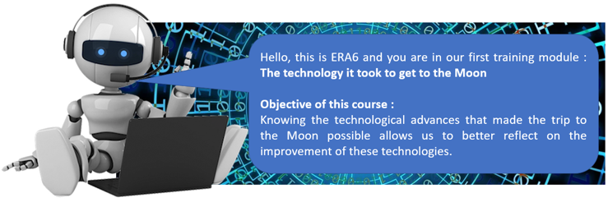

Materials available used for this activity come from
- the science museum of London : https://www.sciencemuseum.org.uk/objects-and-stories/technology-it-took-get-moon
- the following article : https://www.history.com/news/moon-landing-technology-inventions-computers-heat-shield-rovers

CHALLENGE | GO EASILY TO THE PAGE OF THE ARTICLE
Your topic :  ……………………………………………………………..  You have 50 minutes to propose a short video in the format of a documentary presenting the technological and engineering advances implemented during the Apollo 11 mission.  To know your topic, scan your badge Folder “MOOC - Explain activity” | acver.fr/flymeto2

List of all the topics : The spacesuits – The lunar rover – The parachutes – The heat shield – The computers

