Mini MOOC  Fly me to the Moon  EXTEND  Design your Moon camp | 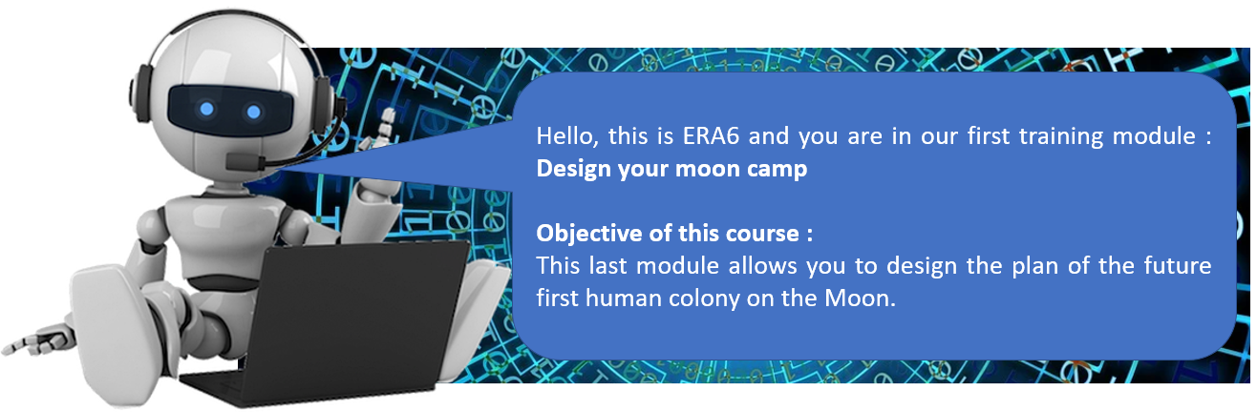

Participate to the moon camp challenge : https://mooncampchallenge.org
Depending on the time allocated to this phase, it is possible to just wonder about the extreme conditions of the space environment and the constraints that this imposes on lunar colonists. But don't forget, the settlers face difficult conditions :
- absence of liquid water
- no oxygen in the atmosphere
- high solar radiation
- no food

CHALLENGE
You have 1 hour to design the map of your perfect Moon camp !
You are free to draw what you want and how you want but include information to explain your project and how the settlers will survive.
You can consult the mooncampchallenge website and/or use the information below or any other source.

Modules that can be used in your mooncamp
PLANT MODULE |  |  | ANIMAL MODULE
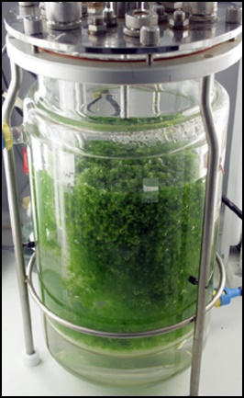  Green algae in a bioreactor | Species: Chlorella vulgaris  Biology: These algae use photosynthesis to produce their organic matter. Photosynthesis is a process that allows green plants to make their organic matter from mineral matter (gas and water) and thanks to the energy of light. To do so, they absorb CO₂ and release O₂.  Requirements for growth: the material and energy requirements to carry out photosynthesis. |  | 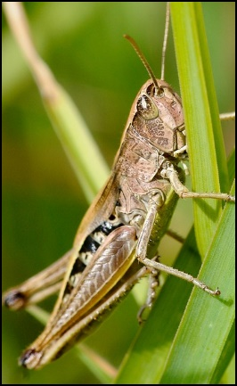  Crickets in rearing module | Species: Migratory cricket  Biology: the development of the larvae lasts about 1 month between hatching and the adult stage.  Requirements for growth :  Crickets are herbivores. They can feed on algae produced in bioreactors. Development is optimal at 30°C.  They need O₂ for the respiration, just like human species.

