SHEET Leaf observation.

- Materials needed: object slides and object coverslips, fine-tipped tweezers, squirts, filter paper, paper towel, stiff-backed razor blades or scalpel, dyes: fluoroglucin-HCl, Sudan III;

- Leaf observation.

Leaves can be looked directly, without any special preparation, under the stereo microscope to observe stomata and trichomes from the outside.

To observe the organization of internal tissues, a transverse section of a dorso-ventral leaf, is cut and mounted in water. Under the light microscope, the epidermis lined by the cuticle, the apical parenchyma, the spongy parenchyma, and, in many cases, the stomata located at the bottom of the stomatal crypts are observed; at the level of the midrib, the conducting bundles in which xylem and phloem mirror the arrangement they have in the stem can be observed.

Stomatal crypts are also visible by making the removal of a small portion of the ventral surface of the leaf, so as to reduce its thickness, and mounting the preparation thus obtained in water, with the dorsal surface facing the observer.
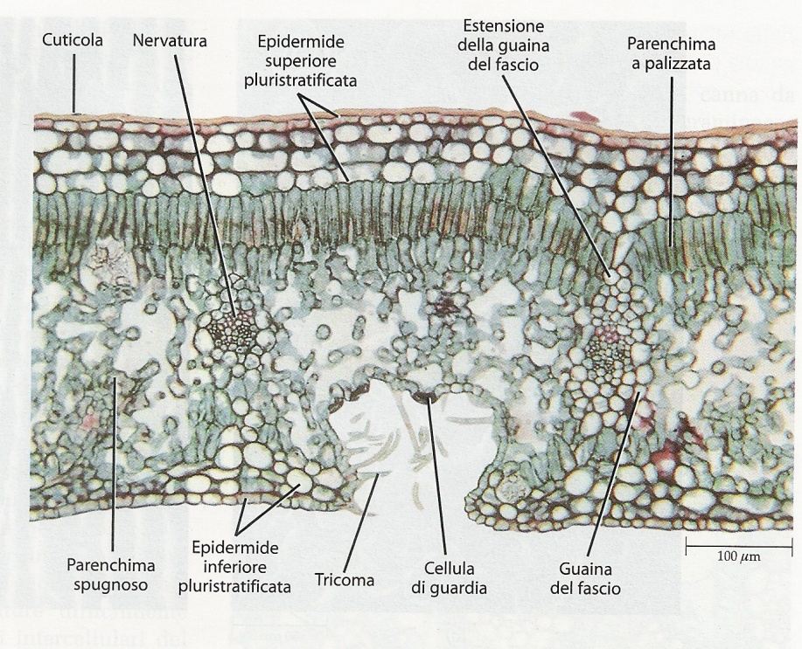

Figure1 Cross section of Neriumoleander leaf.

