WHAT THE LEAVES ARE FOR?
Leaves make the plant's food by converting air and water into glucose (sugar). A leaf consists of:

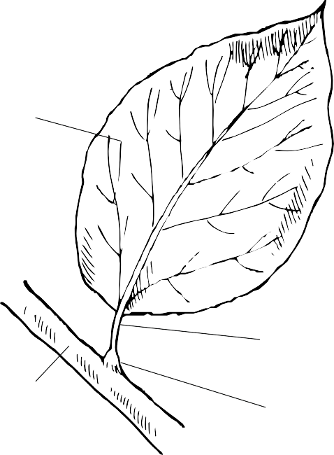
LAMINA

BRANCH

PICCIOLOGUAIN
Usually the leaf is formed
by a flattened part called the lamina and a tough, elastic
stalk called the petiole.

Like the stem, the petiole also has within it very thin vessels that carry raw and processed sap.
The petiole has an enlargement at the base, called a sheath. Sometimes the petiole is missing and the leaf consists only of the lamina and sheath.

Mark the leaves without a petiole with an x.
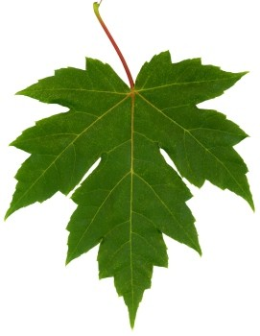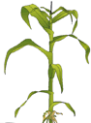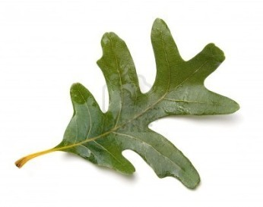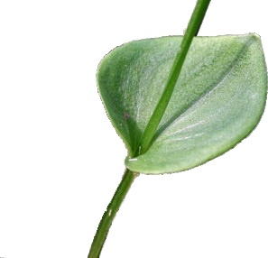

The parts of the leaf
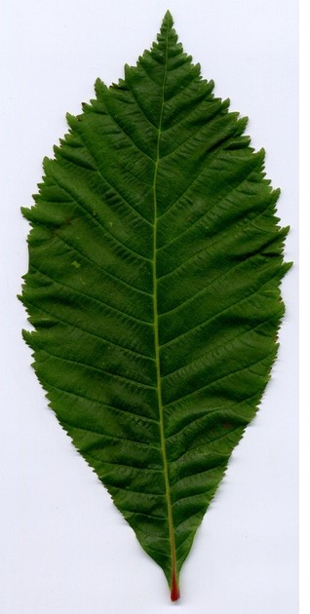Upper page Botton page

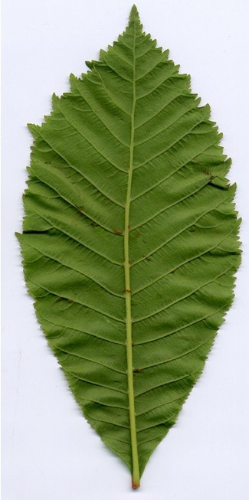lamina

Edge

Ribbings

Petiole

stomas

- The leaf lamina has:
- An upper, upward-facing, darker green page
- A lower page, facing downward and lighter green
- The veins, which contain the vessels in which the lymph flows
- Stomata, found mainly on the lower page; they are tiny openings that let air in and out.
Let's look at some leaves under the microscope

It is very interesting to look at the leaves under the microscope,

Because you can see the veins and especially the stomata better.

The leaves must be quite thin to allow the light of the microscope to

illuminate them.

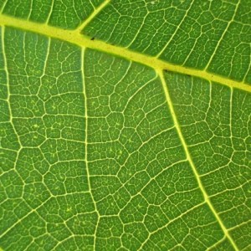
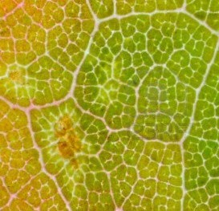
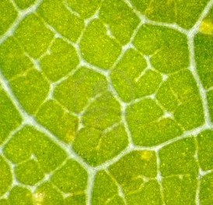
You do not get good results with thick leaves like those of magnolia.

Classification of leaves according to their shape

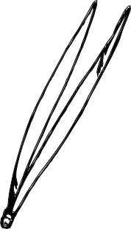
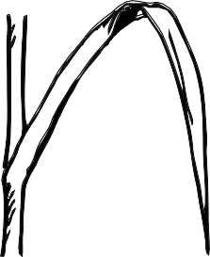
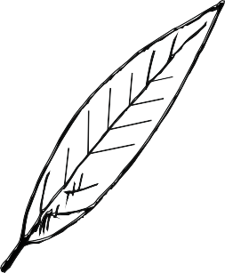
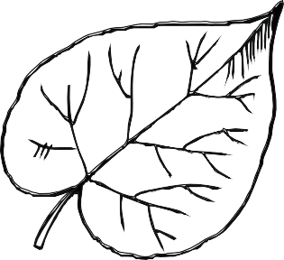

needle-shaped
linear
lanceolata
heart-shaped

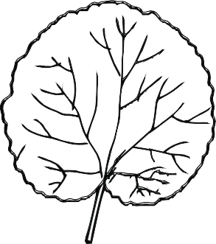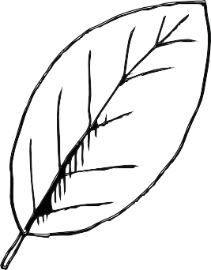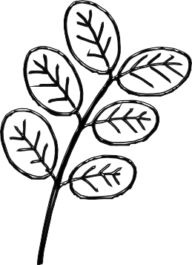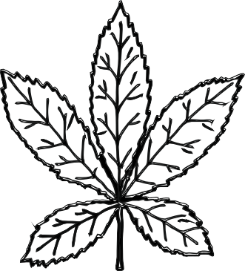
round oval pennata palmate

Classification of leaves according to margin

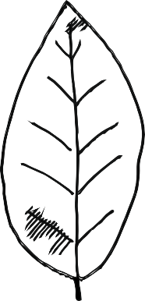
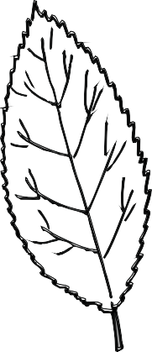
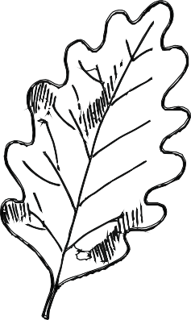
Whole margin serrated margin lobed margin

NAME |  | SHAPE | MARGIN
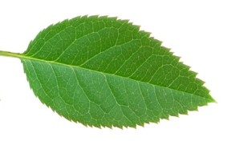
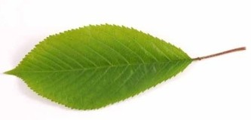
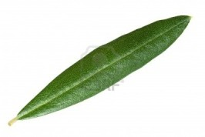
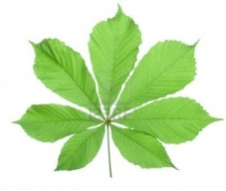
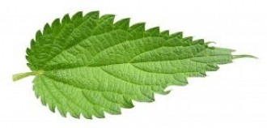
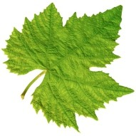 | vite
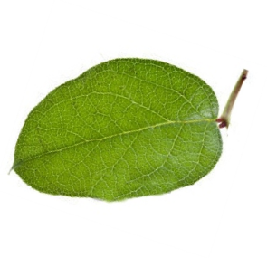
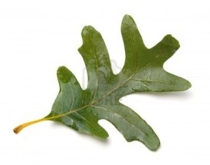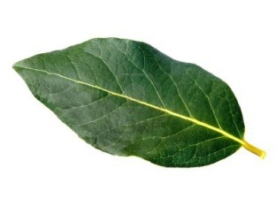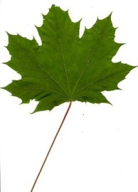

THE CHLOROFILLA

UPPER PAGE
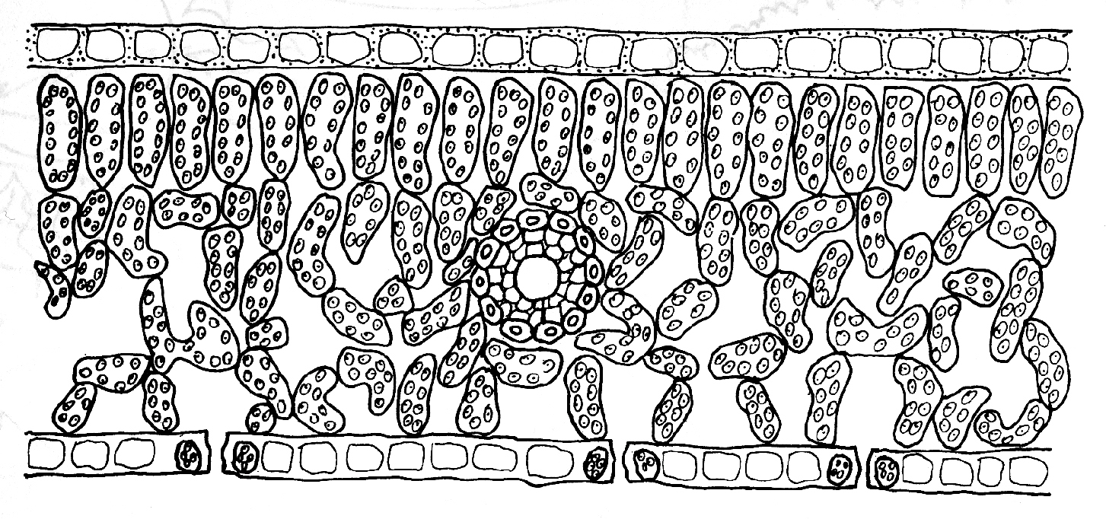
CHLOROPHYLL-RICH CELLS
STOMA
BOTTOM PAGE
STOMA
STOMA
- LYMPH CHANNEL

SUGAR MOLECULES

The leaf is rich in a green substance called chlorophyll.
Chlorophyll is formed by the presence of certain mineral salts and sunlight in the leaf.
EXPERIMENT NO. .1....
Title: the chlorophyll
- Question : Why are leaves green?
2. Hypothesis: Leaves are green because they contain chlorophyll,
which is green.
- Describe the experiment: We lay a leaf on a strip of filter paper and, repeatedly running the edge of a coin over it, draw a green line about 2 cm. from the edge. We pour a few ml of alcohol into a glass and insert the strip so that it touches the alcohol.
- . Analyze the results: Alcohol runs up the paper strip displacing the colored pigment and separating it into different colors which are, starting from the bottom: brown/green: chlorophyll B; bright green: chlorophyll A; yellow: xanthophyll; orange: carotene.
- Conclusion: The leaves are green because they contain chlorophyll; in autumn we see yellow, brown and orange leaves because the chlorophyll that masks the other colors is degraded.

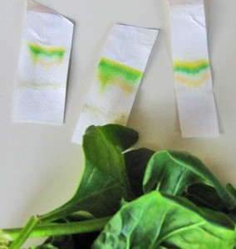

EXPERIMENT NO. .2....
Title: The stomata
..
...
....
....
.....
.....
.....
.....
.....
.....
.....
.....
.....
......
.....
.....
1. Question: What are stomata used for.
2. Hypothesis: The stomata allow oxygen to escape from the leaf
3. Describe the experiment: We put two green leaves in two cups filled with water.
We place one leaf in sunlight and the other in a dark area.
We wait for a couple of hours. M
- Analyze the results: Numerous bubbles formed around and under the
sunlit leaf .
- Conclusion: The gas contained in the bubbles is oxygen, a waste product of chlorophyll photosynthesis. It is released into the air by the stomata.

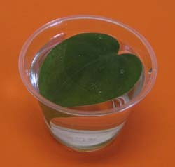

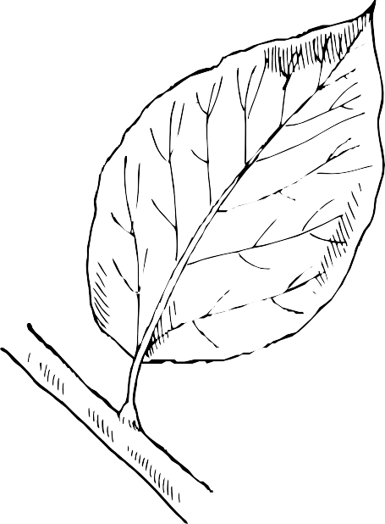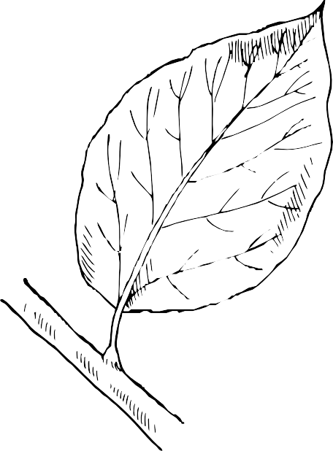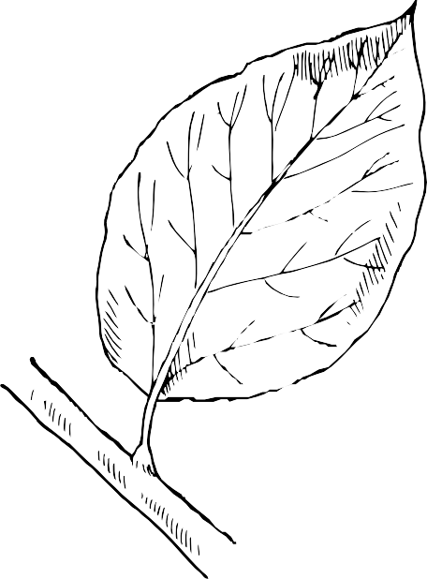

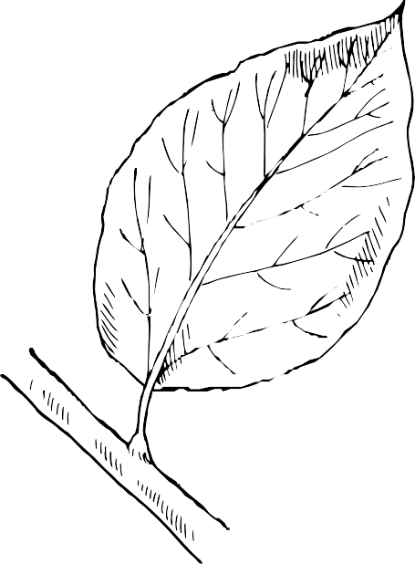
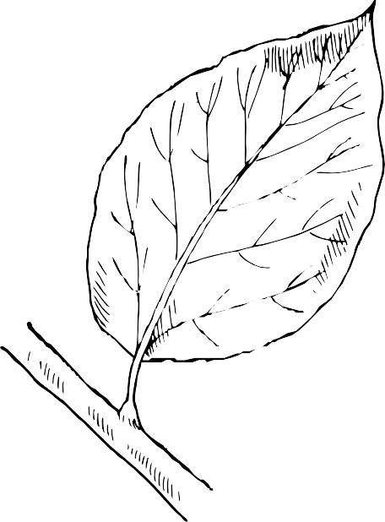
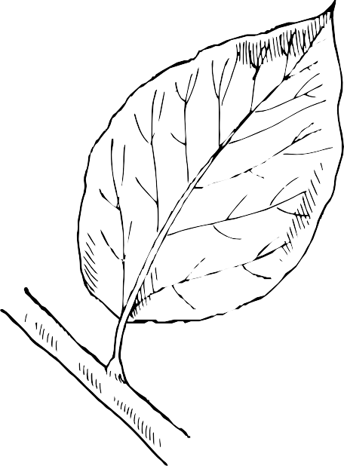

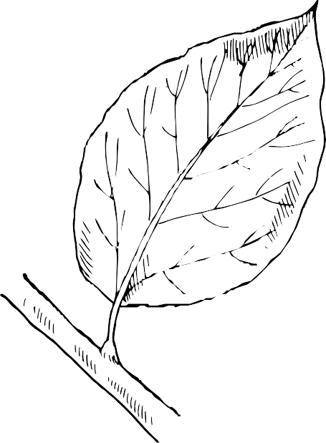
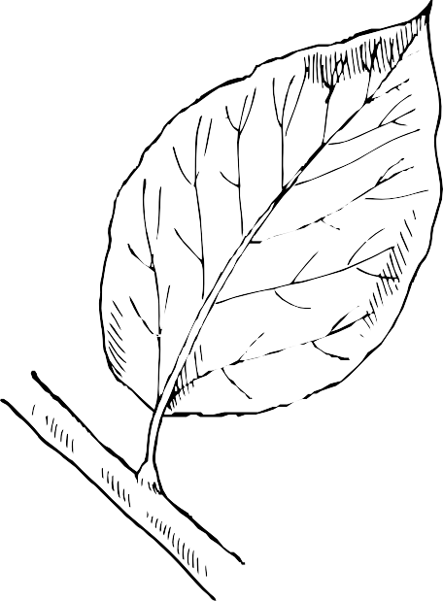
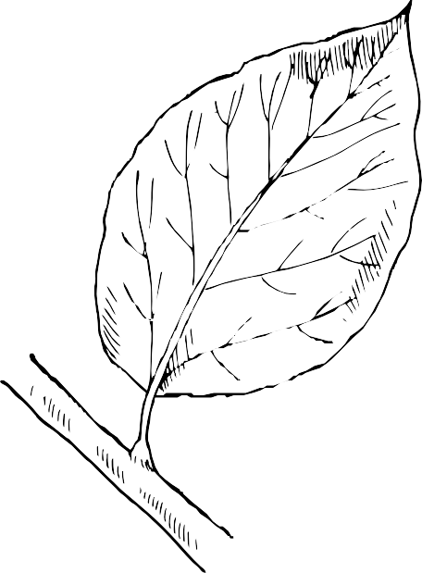

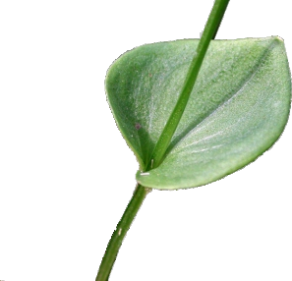

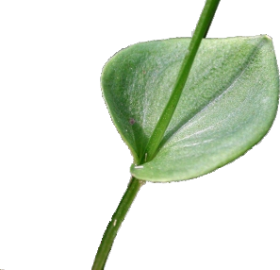

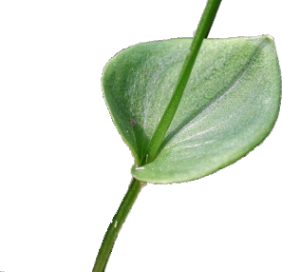

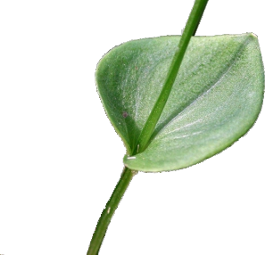

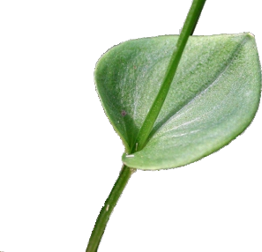

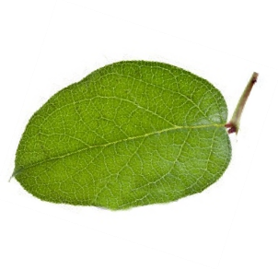

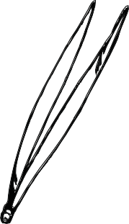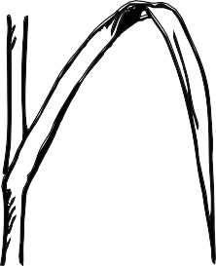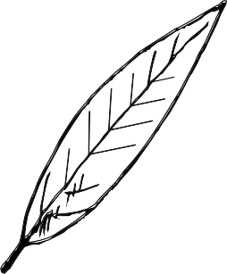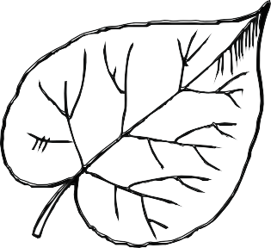

aghiforme
lineare
lanceolata
cuoriforme

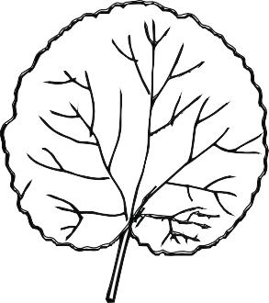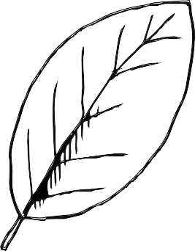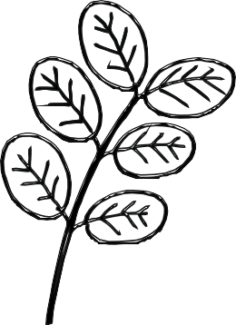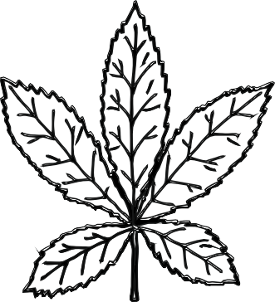
rotonda ovale pennata palmata

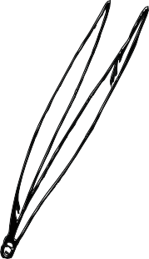
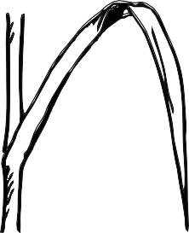
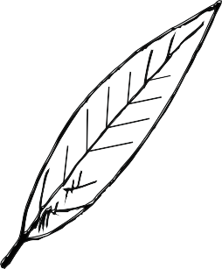
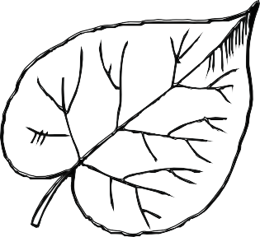

aghiforme
lineare
lanceolata
cuoriforme

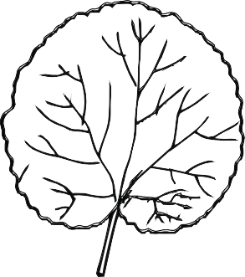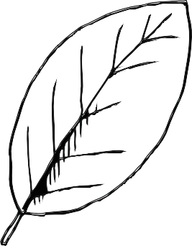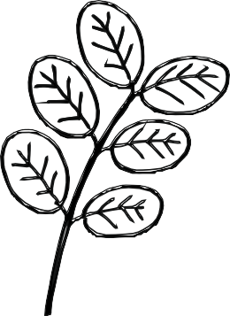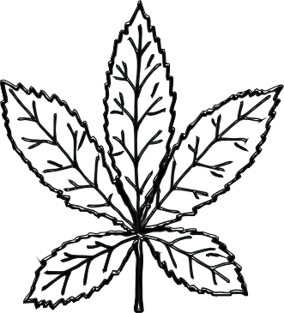
rotonda ovale pennata palmata

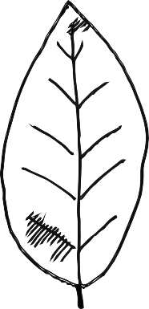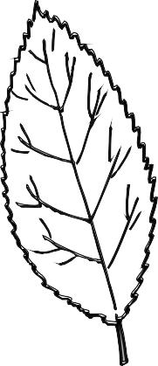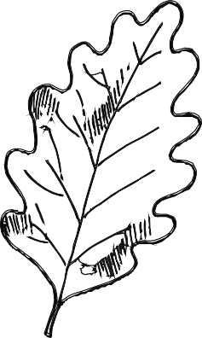
margineintero margineseghettato marginelobato

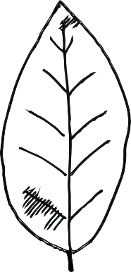
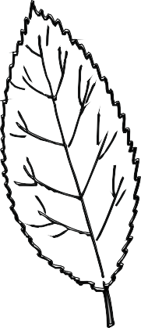
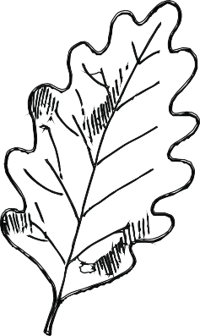
margineintero margineseghettato marginelobato

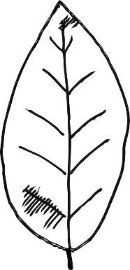
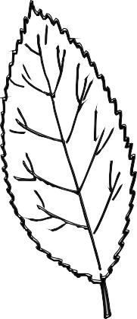
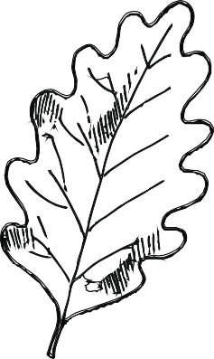
margineintero margineseghettato marginelobato

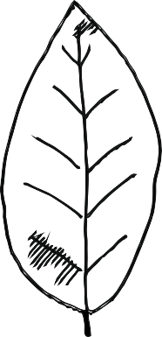
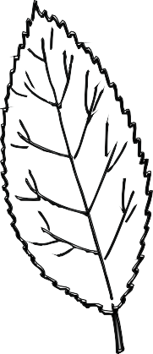
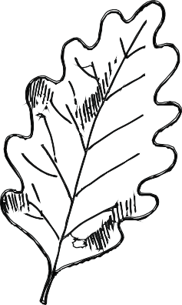
margineintero margineseghettato marginelobato

