ANNEX 4 :Worksheet (The basics of the photography in explain phase)

Let’s study the basics of photography
1.
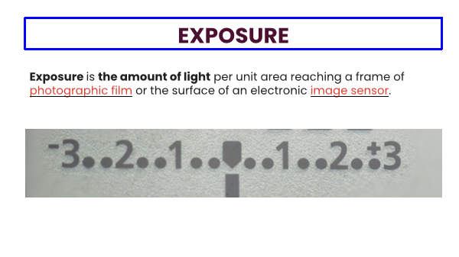
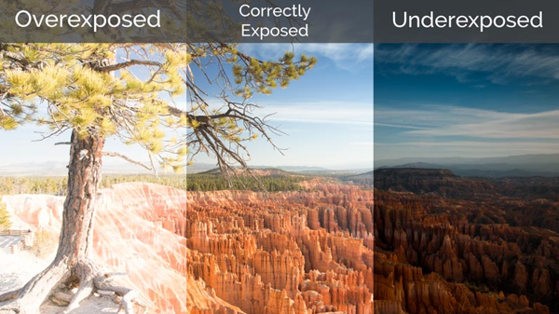
2. 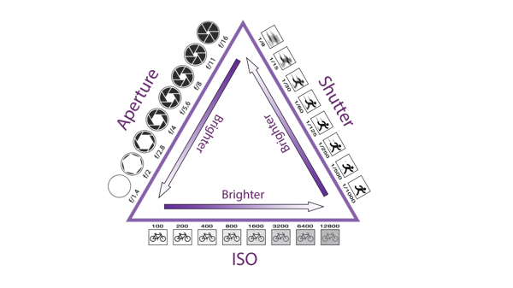

3.
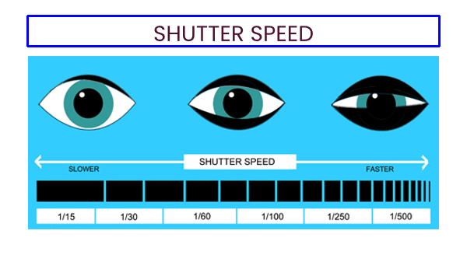
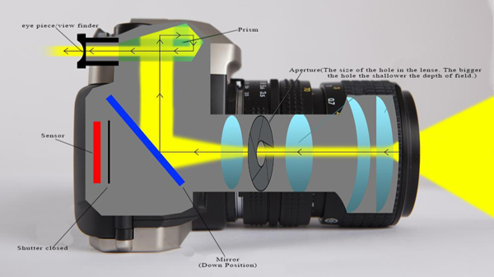
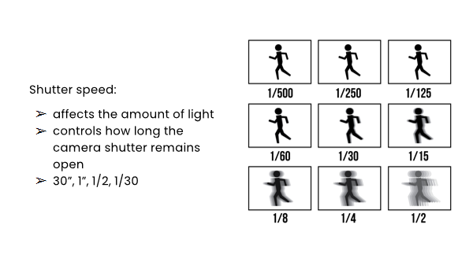

4.
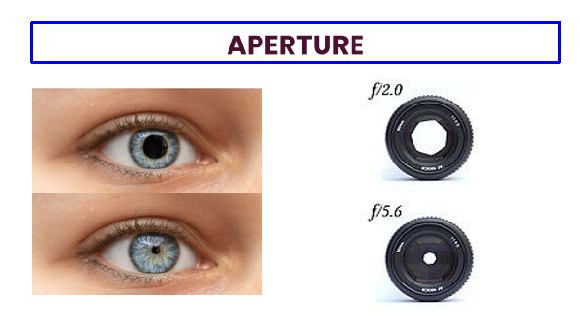
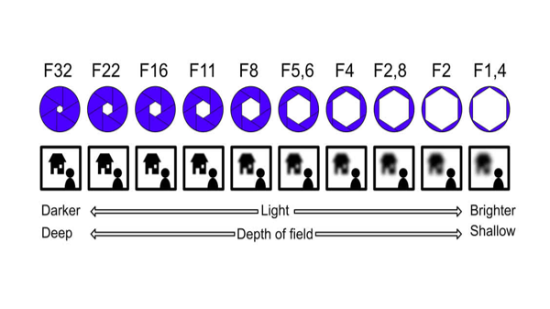
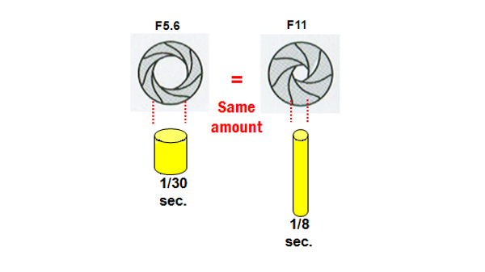
5.
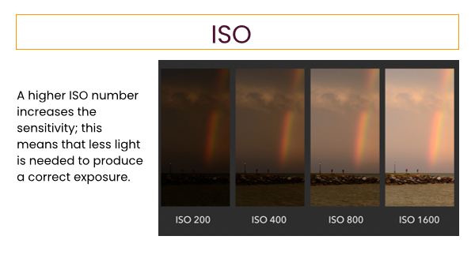
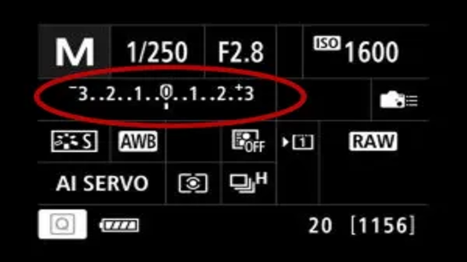
II. Let’s try “EXPOSURE TRIANGLE SIMULATOR”

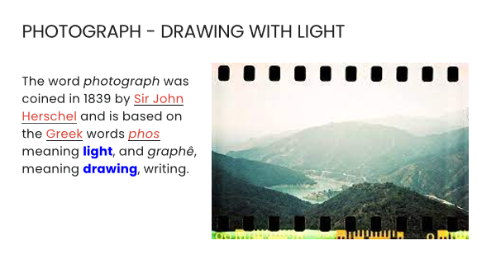
III. You can literally draw with light! Let’s take photos with light.
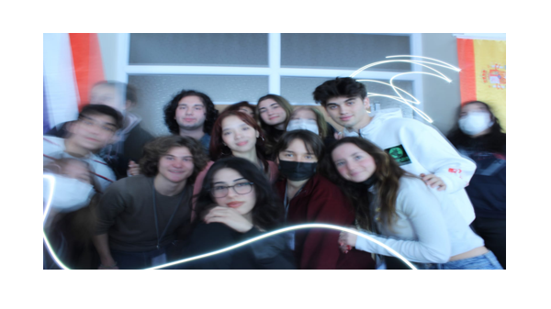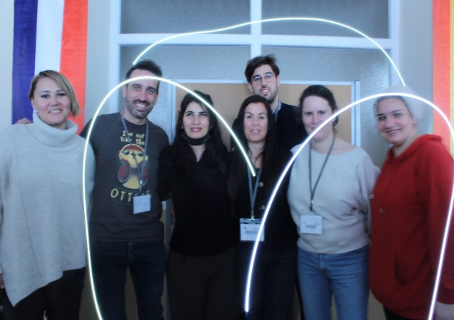
IV. Visit www.digital-photography-school.com and get more information and some tips about digital photography- self discovery- and take some notes
MY PHOTOGRAPHY NOTES
____________________________________________________________________________________________________________________________________________________________________________________________________________________________________________________________________________________________________________________________________________________________________________________________________________________________________________________________________________________________________________________________________________________________________________________________________________________________________________________________________________________________________________________________________________________________________________________________________________________________________________________________________________________________________________________________________________________________________________________________________________________________________________________________________________________________________________________________________________________________________________________________

