**ANNEX 2 : Worksheet ( The right sequence and some information about the photos in explore phase )**

**Resource used : https://www.scienceandmediamuseum.org.uk/objects-and-stories/history-photography**

**Let’s check the right sequence and get some extra information about the photos**

**1**.

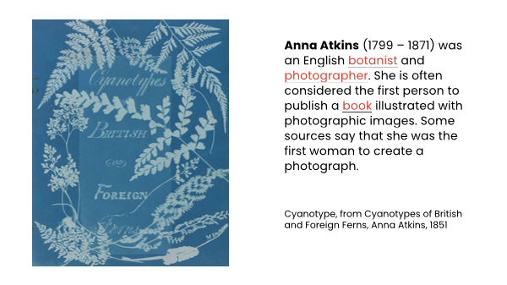

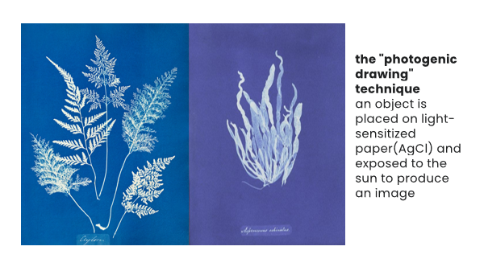

**2.**

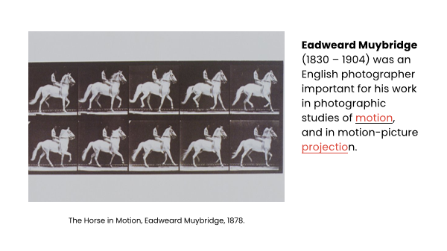

**3.**

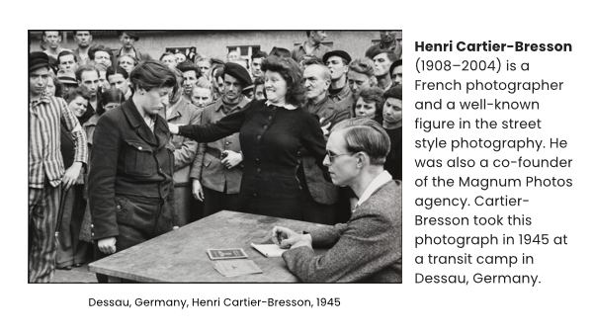

**4.**

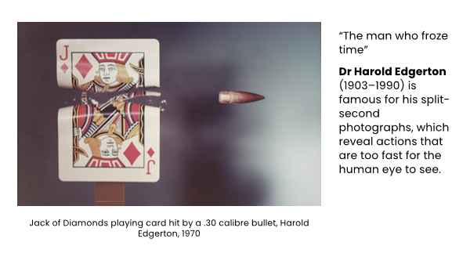

**5.**

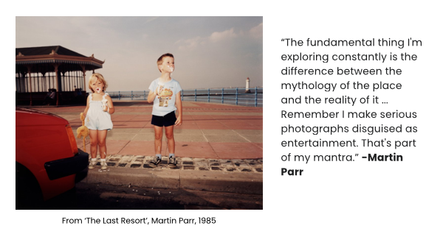

**6.**

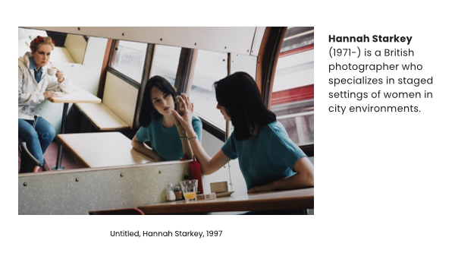

**7.**

