ANNEX 5 : Activities’ Sheet ( Workshops’ Instructions at each Activity Station)
There are four activity stations .Stop at each and participate in the workshops required.
Activity Station 1 : Shaving the balloons (Ice breaker- Warmer )
Shave the balloons
Activity Station 2: Making soap and lip balm (Chemistry, Maths, Art)
Resource Used : https://www.healthline.com/health/how-to-make-soap#finishing
Use the recipe of soap below and make a survey on internet and adapt and develop your own recipe of lip balm. Make your own soap and lip balm.
Recipe of Soap
Ingredients :
20 oz. coconut oil, 10 oz. olive oil, 9 oz. distilled water, 4.78 oz. 100 percent pure lye, 20 to 40 drops of essential oils, colorants (optional), dried herbs or flowers (optional)
Directions :
Measure your ingredients; Set the slow cooker to low ; Add the coconut oil to the slow cooker to melt; Prepare the lye solution- Slowly add the lye to the water ; Stir the solution as you add the lye with a spatula; Set aside the lye solution - cool it for 15 to 20 minutes- ; When the coconut oil has completely melted, add the olive oil and Stir; Continue blending and stirring for 10 to 15 minutes when the oils and lye solution have thickened and look like pudding; Cook on low for 50 minutes; Turn off the slow cooker; Add essential oils and colorants -Mix well ; Pour the mixture into the soap mold. Top with dried herbs, if using.
Recipe of Soap: Make a survey on internet and adapt and develop your own recipe of lip balm.
Activity Station 3: Repeating some tongue twisters and translating them into your languages (Languages)
Repeat the different versions of the same tongue twister below and translate them into your own language. Learn some words in partner languages.
What did a barber say to another barber?
1st version : Bir berber bir berbere: “Bre berber gel beraber, Bir berber dükkanı açalım” demiş.
2nd version: Bir berber bir berbere: “Bre berber, gel birader, biz beraber Berberistan’da bir berber dükkanı açalım” demiş.
3rd version: Bir berber bir berbere: “Bre berber, beri gel” diye, Bar bar bağırmış.
4th version : Bir berber bir berbere: “Gel beraber bir berber dükkanı açalım” demiş.

Activity Station 4: Drawing some moustaches, beards of different periods (Art, History, Politics).
Study some Famous People – Famous Moustaches and draw moustaches and/or beards of different periods
Resource used : https://www.britannica.com/story/famous-mustaches-in-history
- How are those moustaches called and why ?
- Whose moustaches are they- Can you name the owners of the moustaches ?
- Can you tell about the periods when those people lived and important events of those periods ?
1.
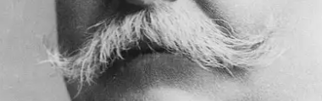
2.
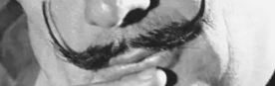
3.
4.
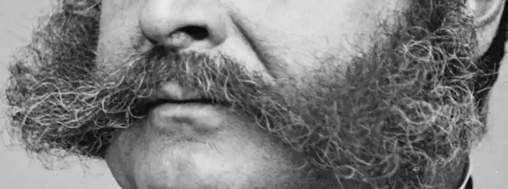

ANSWERS :
1.William Howard Taft : U.S. President William Howard Taft wore the classic “handlebar” mustache.
2. Salvador Dalí: It’s very probable that Salvador Dalí was known as much for his unusual waxed mustache as for his Surrealist paintings. Dalí’s corpse was exhumed in 2017, some 28 years after his death, so that forensics experts could collect DNA as part of a paternity suit. They discovered that his mustache was still intact.
3. Adolf Hitler: The fascist dictator was known for his instantly recognizable grooming style. So unmistakable was his “toothbrush” mustache, a type characterized by thick whiskers that span the width of the nose, that it is often called the “Hitler mustache.”
4.Ambrose Burnside : American Civil War general Ambrose Burnside is known as the originator of side whiskers, which were later called “sideburns,” a name inspired by his surname

Doing the activities at each station, let’s visit the School Museum of Barbering History and Culture and answer those questions:
-Can you make some connections between the workshops and the museum ?
-Do you think that it is possible to use museums as alternative teaching environments and use its sources to practise different disciplines?

Take the best photos of the museum objects using the knowledge of photography provided and necessary apps.

