38°N 15°E… where are we?

What’s this activity about?
We chose an important architectural structure, Palermo Cathedral, like a laboratory where it is possible to test different points of view. We chose it because it is one of more important historical building in the center of old city and it is an element that has a strong relationship with one of us, it is along the way to from home to work. For this activity it will use Google Earth Pro App and Google maps to measure Cathedral size (length, wide and height) to calculate its volume. It will test App (potentiality and limits) to verify if it is possible to obtain measure from a photo using proportions.
This activity will help students to improve their use of technology in informed and aware way.

What will students do?
First students will download Google Earth Pro app. It exists for computer, Tablet and mobile phone, (https://www.google.com/earth/versions/). Then they have to test it and try to make some measurements of distances and heights using the ruler function (the app is very intuitive). It is possible that some measure are easier to do with one system than with the other.

Materials
Computer or tablet, Google maps and street view, google earth pro app, a ruler, paper and pen or pencil

Notes
The App exists in all the languages ​​of the partner schools and we have verified that the activity can be developed in all the cities where the schools are located.

Pre-requisites
Concepts of elementary geometry (Pythagoras’s theorem, solid volume, and relationship between similar triangles), unit of measure, physical quantities (space, time and velocity) and their relationship, the scale representation, base statistic quantities (media), concepts of elementary algebra.

Activity description

Palermo Cathedral is the cathedral church of the Roman Catholic Archdiocese of Palermo, located in Palermo, Sicily, southern Italy. It is dedicated to the Assumption of the Virgin Mary. As an architectural complex, it is characterized by the presence of different styles, due to a long history of additions, alterations and restorations, the last of which occurred in the 18th century.
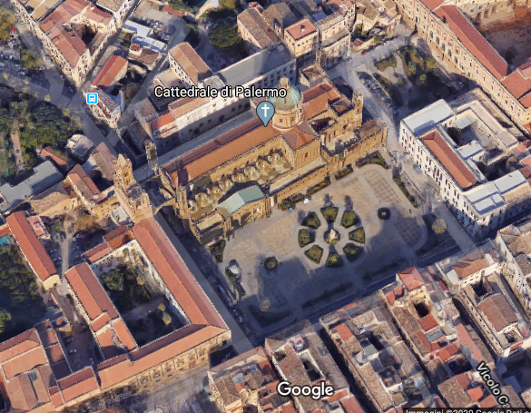

1. Students use Google street view to locate the building, take a photo of the location so they have the contest in which your building is. In this way they have also etiquette for identifying other buildings near it (Google Earth show name only if you click on it). They take two photos: 3D photo and 2D one. In the second one, there are street and it is easy to identify streets around Cathedral in this case. The little circle in figure are people.
Use of 2D and 3D photo should stimulate student to looking at our planet in different manner and, if you would like it, to allow you to introduce first information about 2D and 3D photo, showing that the difference between them is their base unit (pixels for 2D and Polygons for 3D).

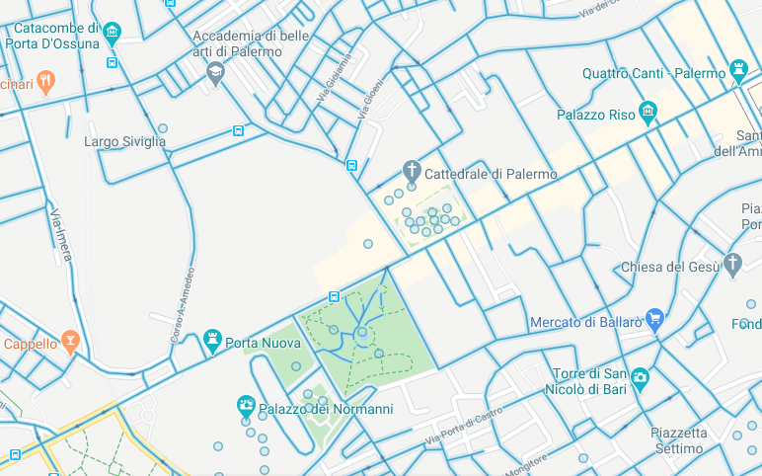
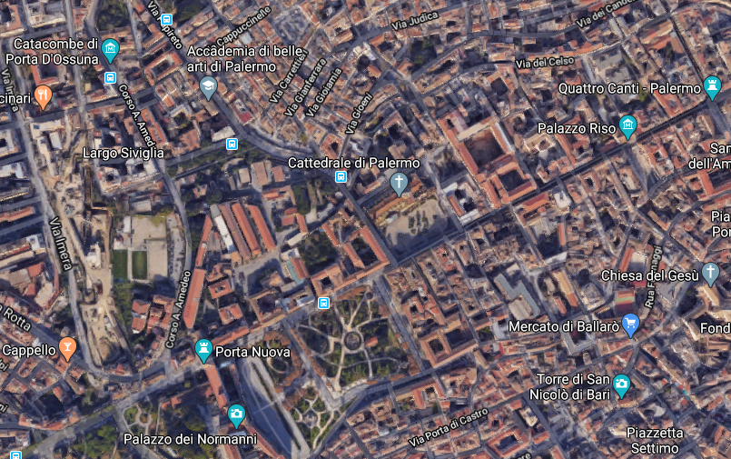

2. Students take an enlargement 2D photo and 3D one in which they see only Cathedral and streets around it and compare them. Streets are, running clockwise from top left: via Incoronazione, via Simone di Bologna, Via Vittorio Emanuele, via Matteo Bonello. In this case they can choose if they use the app or maps, it is equal. They will measure perimeter of Cathedral plus garden in front of it.
If they use maps, check a point on map +ctrl, a new menu appear and in the bottom there is measure distance. Appear a box, put points to complete perimeter and in the box they have measure of it and area.
If they use the app at top of it there are tool bar and the ruler. In the box of ruler, using Polygons to obtain the same result.

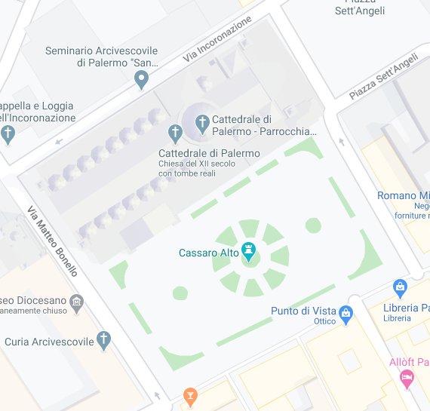
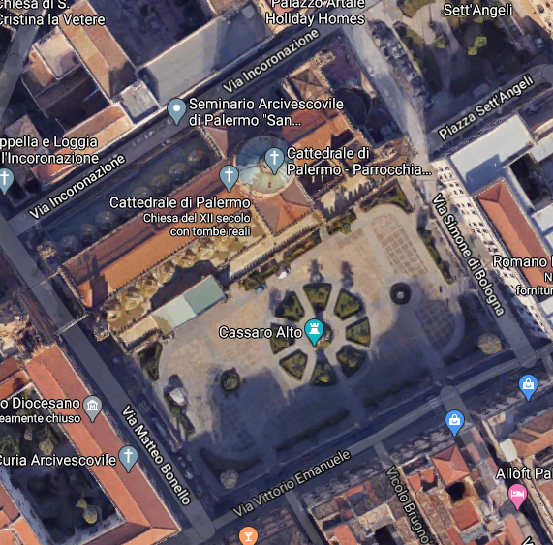

3. Students can use ruler to check measure taken in real-life and verify how much their measurements are different from google it. In figure an example of measurement with maps.
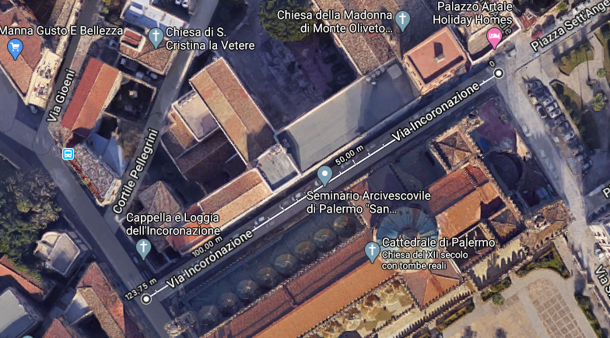
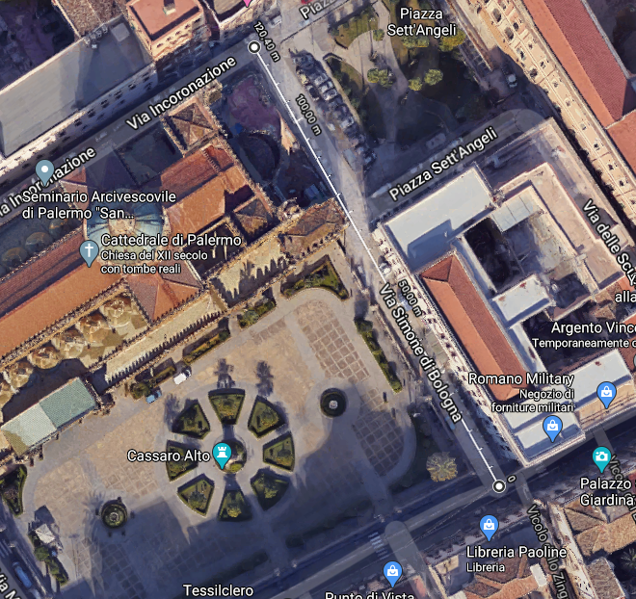

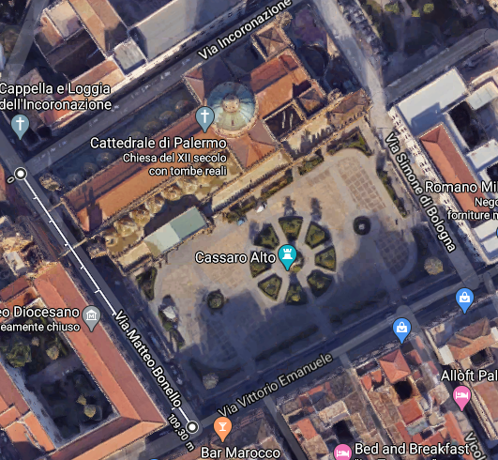
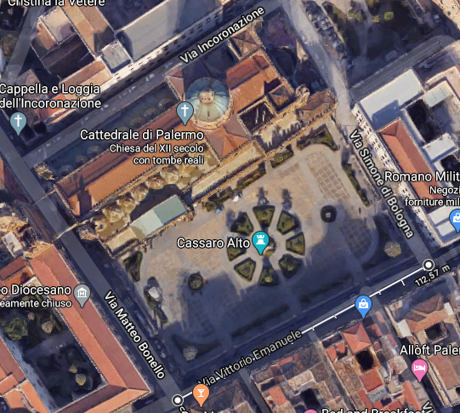

In figure perimeter and area.

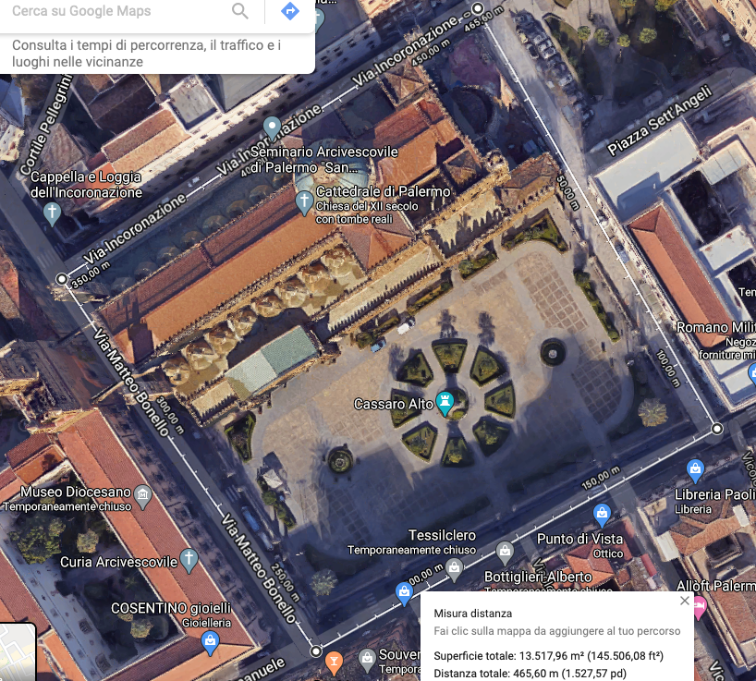

Authors: Valeria Greco

https://en.wikipedia.org/wiki/Palermo_Cathedral for more information

