What time is it?

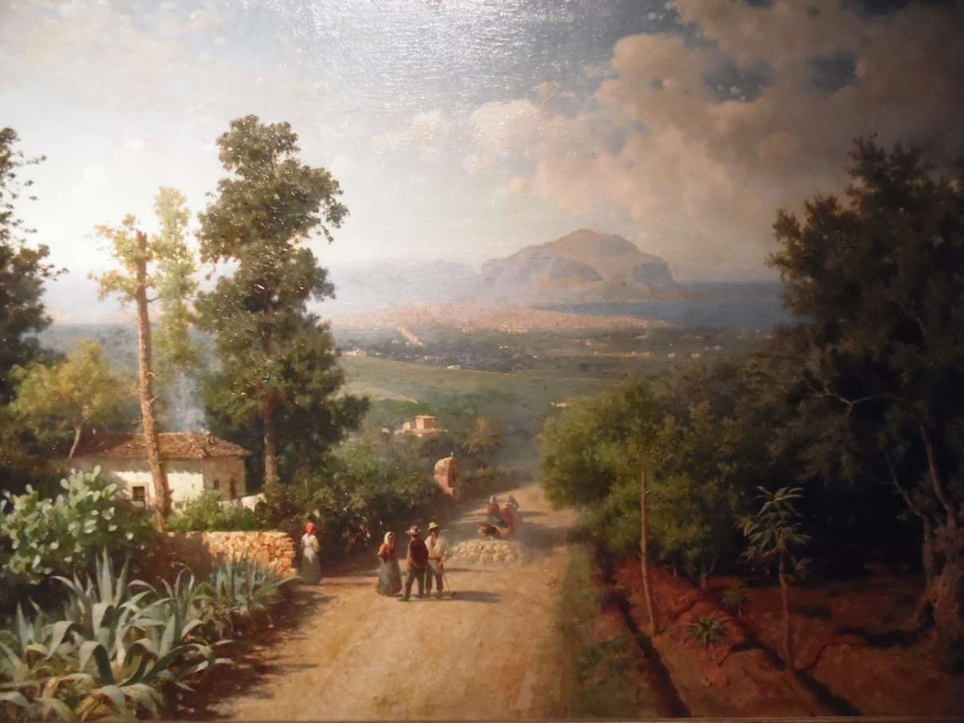

What’s this activity about?
We use a painting to observe the relationship between art and science. Today, we get used to a neat split of disciplines, science and humanistic disciplines and inside science ones too. This is a cultural heritage from nineteenth century knowledge. But if we stop to think about, artists were also a little scientists, because to paint light, to draw the depth, they had knowledge of physic and chemistry such that they could represent reality in an almost truthful way.
For this activity we use Francesco Lojacono painting that is showed into the Modern Art Galley of Palermo (GAM).
Veduta di Palermo is an oil paint on canvas. It was exhibited for the first time in Palermo on the occasion of the XII Congress of Italian Scientists.
The painting shows the landscape of the Conca d'Oro at the end of the 19th century. In the first version the title was completed with the indication from the street of Santa Maria di Gesù.
This activity will help students to improve their skill to observe and don't take anything for granted.
Francesco Lojacono: Veduta di Palermo (1875)

Author: Valeria Greco

