Man is a measure (mètron) of all things

What’s this activity about?
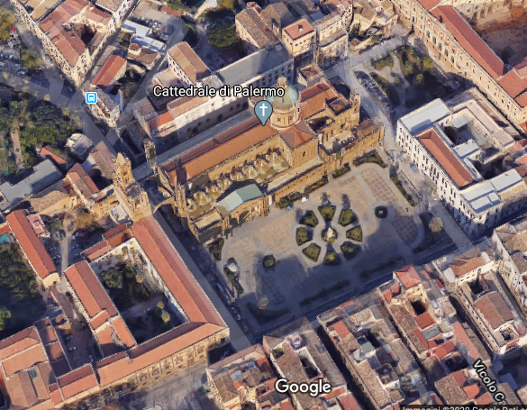
Man is a measure (mètron) of all things, is a real-life activity and its focus is the knowledge of relation between us and buildings around us, and how we can understand their size using our body at first guess. We chose an important architectural structure, Palermo Cathedral, like a laboratory where it is possible to test different points of view, to measure its size using different measure unit to calculate, for example, its volume and to include it in urban space in which it is.
This activity will help students to understand how to apply curriculum learning in real life.

What will students do?
First, students will measure two external side of ​​Palermo Cathedral using a different measure unit like their steps then, they observe the different results and investigate how to have an unique unit and calculate area. Second they will measure the height of higher architectural element and then they calculate maximum volume. Third they will measure two internal side and height of Cathedral, and also in this case they will do with their steps or using flooring for modules (Palermo Cathedral has got it). Then they calculate internal area and volume and try to investigate if the real volume is a media of two results.

Pre-requisites
Concepts of elementary geometry (Pythagoras’s theorem, solid volume), unit of measure, physical quantities (space, time and velocity) and their relationship, elementary trigonometric functions, the scale representation, base statistic quantities (media).

Activity description

Palermo Cathedral is the cathedral church of the Roman Catholic Archdiocese of Palermo, located in Palermo, Sicily, southern Italy. It is dedicated to the Assumption of the Virgin Mary. As an architectural complex, it is characterized by the presence of different styles, due to a long history of additions, alterations and restorations, the last of which occurred in the 18th century.
We chose Cathedral as laboratory because it is one of more important historical building in the center of old city and it is an element that has a strong relationship with one of us, it is along the way to from home to work.
The first step is to calculate the area of ​​the building which it has got a rectangular base, for hypothesis. It is needed to measure the short side and the long side to find it. Normally the meter is used to estimate a distance, here you want to try to find a personal unit of measurement.

1. Ask your students: “We want to measure external sides of this building but we don't have a meter how could we do?”
It may take some discussion for the students to understand how to resolve the problem, and with your tips (like can we use ourselves? Can we use something that has a relationship with length? For example, can we use our steps?) they maybe conclude that their steps are a possible solution.

Authors: Giulia Cordone and Valeria Greco

Credits:
All imagines are taken from Google Maps, Google Streets view and Google Earth Pro

Man is a measure of all things, of those which are for what they are, and of those what are not for what they are not (Protagora, fr.1, in Platone, Teeteto, 152a)
https://en.wikipedia.org/wiki/Palermo_Cathedral for more information

