Quadrant
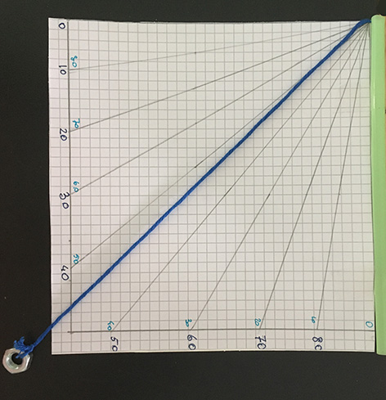

Historically, quadrants are measuring and calculating devices that was developed over one thousand years ago to measure time and to calculate a person’s location on the earth.
Quadrants may have originated with ancient Greeks. The earliest surviving examples, constructed by Arab and Persian craftmen, come from the 9th through the 11th centuries. The early astronomical instruments were able to measure the angular height, or altitude, of stars above the horizon. Also an observer could use a single quadrant measurement to calculate the time of night if he or she knew the current date.
The quadrant we will construct will measure the altitude of objects above the horizon.

Science theme
Astronomy and geometry

Science skills
Following procedure
Instrument-making

Materials
- Cardboard
- Squared Sheet
- Drinking straw
- Small weight
- Piece of dark thread or a string, 40 cm long
- Pencil
- Eraser
- Ruler
- Protractor
- Scissors
- adhesive tape
- Glue

Procedure

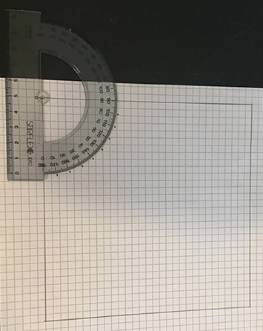
Drawing a 15 cm square on squared paper. With a protractor, mark angles from 0° to 90° as in figures.
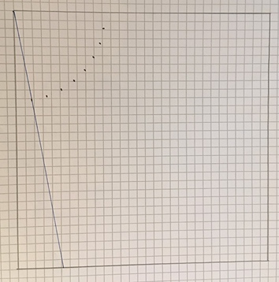

Write angles clockwise and counterclockwise.
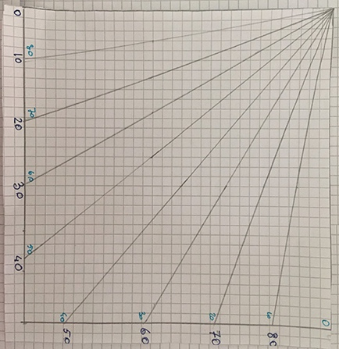

Secure the straw with an adhesive tape on one edge where there aren’t indications of angle as in figure.
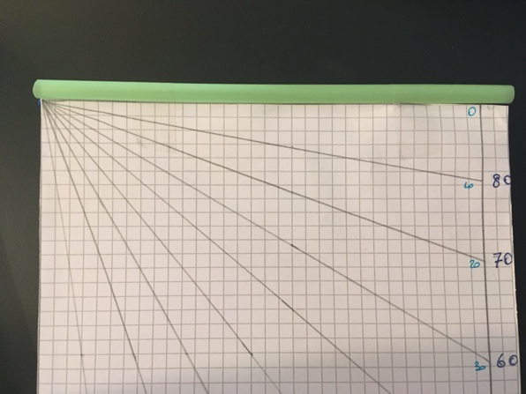

Tie the small weight to one end of the string. Put the string along the other edge where there aren’t indications of angle and secure it in quadrant back.
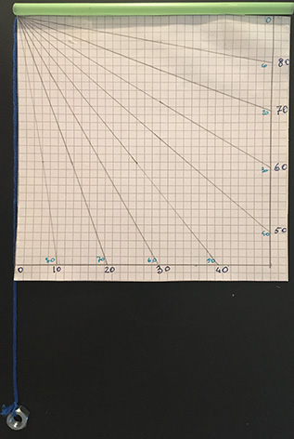

How to use:

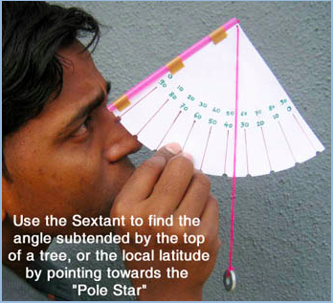

Credit
Last image from http://www.arvindguptatoys.com/toys/simplesextant.html

If you like you can construct the quadrant explain here http://www.arvindguptatoys.com/toys/simplesextant.html

Authors: Valeria Greco

